Step 1:

Get me the IP address of a particular domain (guvi.in) using nslookup guvi.in

Screenshot mentioned below

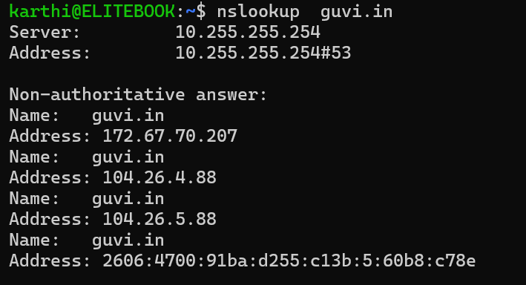

Step 2:

And cpu/server of memory uses using top command Screenshot mentioned below

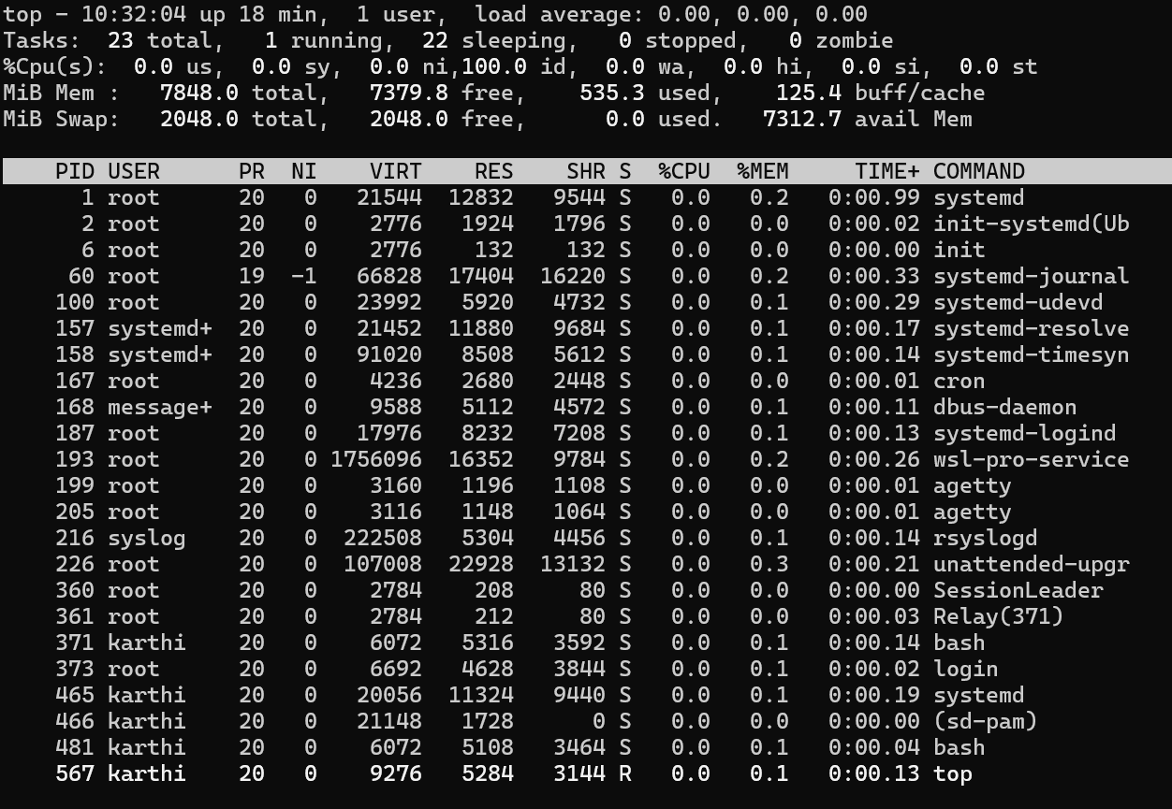

And the Connection Between the two node using Ping Command So using Ping Command iam Checking the Destination IP or Hostname

Ping guvi.com its for continuously without using this command ping –c 5 guvi.in so 5 times only

Screenshot mentioned Below

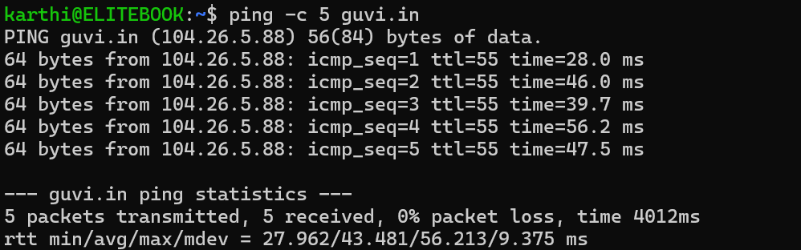

Step 3:

Whether the Port is opening or not need to check using command netstat –tlun | grep :9000

Screenshot mentioned Below it showing nothing because guvi.in is not in the 9000 port but iam trying to get that instead iam using google.in for 443 it getting and same for that guvi.in 443 port is also open

So the conclusion is 9000 port is not opening for guvi.in

Screenshot mentioned Below:

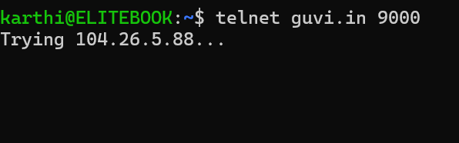

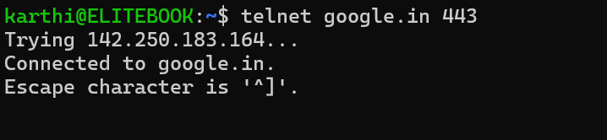

This is for google.in for 443 port

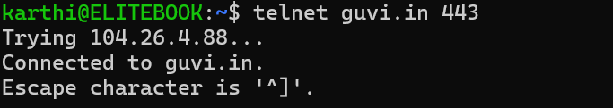

This one is for guvi.in 443 port